Name: Justin V Kalappura
Roll No: 10
Batch: MCA
Date: 09/05/2022

NETWORKING & SYSTEM ADMINISTRATION LAB

Experiment No.: 14

Aim:
Write a shell scripting program to display cureent date and calender(month).
Procedure:
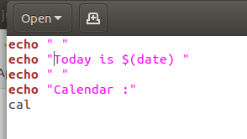

Output Screenshot:

